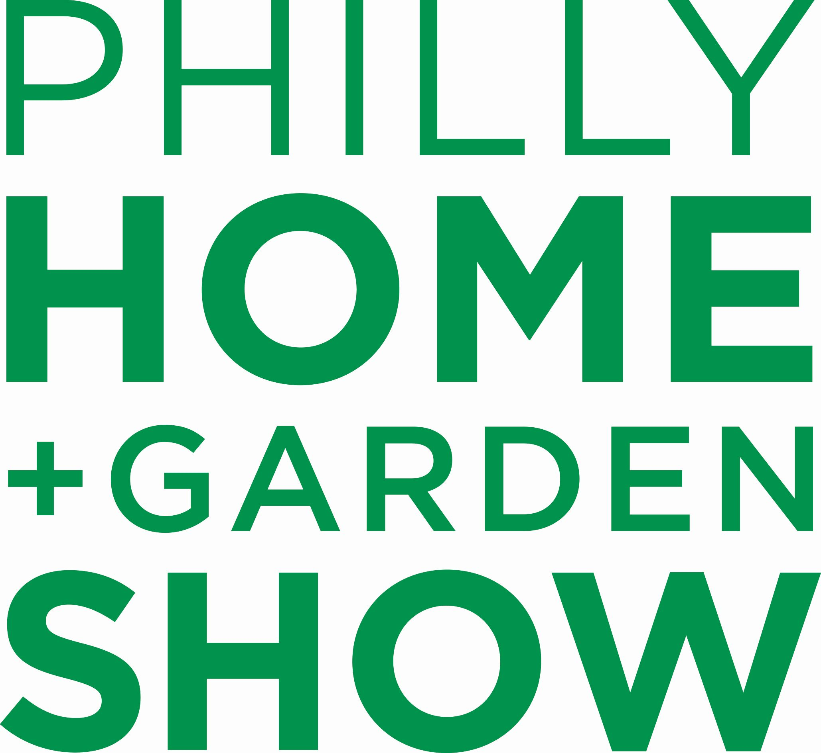

CONTACT:
Elise Brown
ebrown@pavone.net
215.990.6955

More than 300 exhibitors, celebrity home renovators, and acres of inspiration
at Philly Home + Garden Show, Feb. 14-16 in Oaks, PA

Visitors can also experience special Valentine’s Day weekend activities

PHILADELPHIA (JANUARY 22, 2020): The newest home design and improvement trends, products, ideas, and solutions can be experienced at the 2020 Philly Home + Garden Show for three days only, from Friday, February 14 through Sunday, February 16 at the Greater Philadelphia Expo Center at Oaks (100 Station Ave., Oaks, PA, 19456). In addition to more than 300 exhibitors in almost every home and garden category, the premier suburban home improvement and remodeling show will also feature celebrity experts, and special Valentine’s Day weekend activities and events.

Popular TV home show stars who’ll share their experiences and tips with visitors are Eric and Lindsey Bennett of HGTV’s “Desert Flippers” on Friday, Feb. 14 at 6 PM and Saturday, Feb. 15 at 11 AM and 2 PM, and Barry Williams of HGTV”s “A Very Brady Renovation” and “The Brady Bunch,” who will entertain visitors Saturday, Feb. 15 at 1 PM.

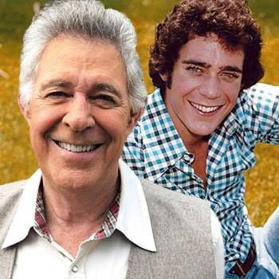

Eric & Lindsey Bennett of “Desert Flippers” (left) and Barry Williams of “The Brady Bunch” and “A Very Brady Renovation” will be part of the 2020 Philly Home + Garden Show

Show Manager Jenna Naffin said, “For the 5th Philly Home + Garden Show, we’re presenting more features and special events than ever before. Visitors can take a romantic stroll through the lush landscapes and plantings in the Garden Hall while enjoying some locally-made wine or vodka, learn how to make a Valentine’s Day floral arrangement, create their own home decor project, and even participate in a yoga stretch together.”

Highlights of the 2020 Philly Home + Garden Show include:

- LOVE GROWS HERE: More than 7,500 square feet of gorgeous, inspirational gardens designed by some of the region’s top landscapers, with the Pop-Up Flower Shop, Garden Market, Succulent Bar, and Wine Garden conveniently located nearby

- THE CONNECTED BACKYARD: Built by Burke Brothers Landscape Design, powered by Xfinity - This feature garden’s smart home technology shows how you can enjoy the same comfort, convenience and security in your outdoor space that you're accustomed to indoors

- DO YOU DIG IT?: Go beyond bulbs and blooms to learn from the experts about such rewarding pursuits as edible landscaping, planting a children's garden, and raising chickens

- MAKE IT, TAKE IT WORKSHOPS: Free hands-on sessions led by local designers that teach visitors new project skills while they make a decorative or useful new item to bring home

- THE BARKING LOT & DOGGY FASHION SHOW: A portion of sales from this pet market filled with treats and accessories benefits PSPCA, whose adorable, adoptable dogs will strut in the Doggy Fashion Show Sat. Feb. 15 at 12 PM

- ERASE YOUR E-WASTE: Visitors can bring unused or outdated electronics to be responsibly e-cycled by PAR-Recycle Works, a local nonprofit electronics recycler

- WINE & VODKA TASTINGS: Local wine tastings throughout the show by The Renegade Winery, and tastings of locally-distilled Kiki Vodka on Fri. Feb. 14 from 5 PM to 7 PM

- FLORAL DESIGN CLASSES: Sign up to attend any of six floral design classes that will teach you how to make beautiful, unique arrangements like the pros

- YOGA STRETCH: Sun. Feb. 16 at 10 AM, join 98.1 WOGL-FM morning host Marilyn Russell and instructor Susan Madden-Cox of Ocean Earth Wind Fire yoga studio in an invigorating yoga session for all ages and abilities (just bring mat and towel)

- TRADE DAY: Sun. Feb. 16, free admission for all home-related tradespeople (with valid ID), to highlight the skilled labor shortage and support the local home improvement industry

- SEPTA DAY & HERO DAY: Fri. Feb. 14, free admission for all SEPTA Key Card holders, and for all ID-bearing active or retired military, nurses, firefighters, first responders, and teachers

Philly Home + Garden Show hours are Fri. Feb. 14 from 11 AM to 9 PM; Saturday, Feb. 15 from 10 AM to 9 PM; and Sunday, Feb. 16 from 10 AM to 6 PM. Admission is $11 for adults ($9 in advance), and free for children under age 12. Parking is free at the Philly Home + Garden Show. For all show information and tickets, visit www.phillyhomeandgarden.com.

- Twitter @phillyhomeshow / #phillyhomeshow
- Instagram @phillyhomeshows
- Facebook https://www.facebook.com/events/510173409534784/

# # #

About Marketplace Events
Marketplace Events creates vibrant expositions connecting enthusiasts with experts, products and services in dynamic face-to-face environments. The company produces 51 consumer home shows in the U.S., 16 in Canada, five holiday shows, two bridal shows, and one spring boutique. The 75 combined events, in 34 markets, currently attract 22,000 exhibitors, 1.9 million attendees, and another 3 million unique web visitors annually. From 15 offices, the 170-person staff produces some of the most successful and long-running shows in North America, including market-leading shows in Minneapolis, Philadelphia, Indianapolis, Vancouver, Calgary and Montreal - some of which have thrived in their markets for more than 75 years. www.marketplaceevents.com

Media Contact: Elise Brown, ebrown@pavone.net phone 215-990-6955

